Firmware
Current version | v1.01
Status | Completed, ready for production
Supported HW | EEZ PSU H24005 (Arduino Shield r3B4 or newer)
Simulator | Windows, Linux, OS X
File repository | https://github.com/eez-open/psu-firmware
License | GNU GPLv3
Contributions | C4.1 (Collective Code Construction Contract)

The PSU firmware program is an Arduino sketch that must be uploaded to the Arduino board connected to the Arduino shield module. Instructions about firmware downloading, compiling and uploading can be found here.

The firmware sketch was tested with the Arduino IDE 1.8.2 and requires three additional libraries that come with the source code distribution. When they are properly installed you should see them in the Arduino IDE as shown on the picture below.

Please download and install Ethernet2 and SCPI parser directly if Arduino IDE reports errors during compilation.

Software simulator
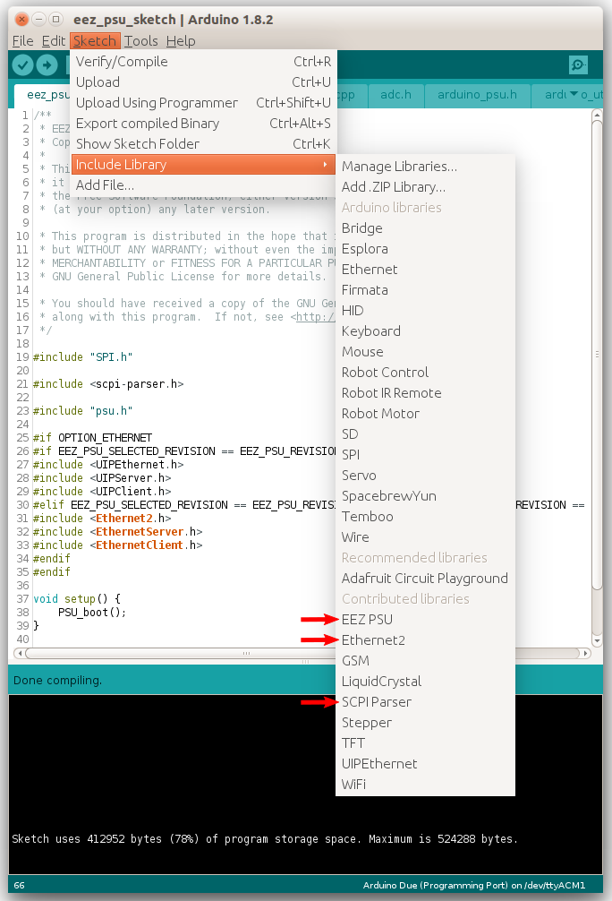Fig. 1: Installed additional Arduino libraries
A unique feature of the firmware is the capability of running it without the underlying hardware. There is a software simulator (described in Section 9 of the SCPI reference guide). Another important firmware feature still rare (or almost non-existent) within the DIY/open hardware community is comprehensive support for SCPI. The SCPI represents the core of the firmware; it allows remote control of the bench power supply using various application suites designed for instrument control. For example, one can use the Keysight Command Expert freeware for the bench power supply control and monitoring.

Memory usage
Arduino Due
Sketch uses 415712 bytes (79%) of program storage space. Maximum is 524288 bytes.

Roadmap
Version | Description | Release  time frame
M1  (Milestone one) | SCPI compliant firmware for the power supply as an SCPI device class that includes programming of voltage, current, OVP (over-voltage protection), OCP (over-current protection), OPP (over-power protection) and OTP (over-temperature protection), output measurement, ADC/DAC voltage and current calibration, output control, remote sense control, power up control, system date/time (using RTC), diagnostic reporting, beeper, Ethernet and serial (via USB) communication. It also include support for complex SCPI status registers structure. | 12/2015
M2 | Adds support for a local console (within the PSU) based on a color TFT touch screen display as an input device that removes the requirement for many buttons and switches on the front panel. It also enables better user interaction thanks to use of a “pointing device” (i.e. your finger on the touch-screen) that commercial devices in general still do not offer.  Both portrait and landscape TFT display orientation will be supported and display pages will be generated using the EEZ Studio visual toolkit. | 10/2016
M3 | Channel coupling (parallel, series) with balancing, channel tracking, AUX temperature sensor OTP settings, fan speed control, negative power monitoring (power sink) for down-programmer protection, system lock/password management. | 12/2016
M4 | Encoder support, “YT view” for displaying output values, arbitrary waveform generator, triggers, initial SD card support. | 03/2017
M5 | Dual channel current range, a first time installation wizard, improved output value precision. | 05/2017
v1.0 | Digital I/O support, Ethernet settings, serial port settings, support for NTP (real-time clock synchronization). | 06/2017
v1.01 | Calibration bug fix for older Power board’s (r5B9). The native USB port is set as default one. A few minor improvements. | 07/2017
v1.1 | SD card file management, Data logging, support for *SRQ (service request) over Ethernet, etc. See also GitHub Milestones section. | ?

Downloads
{jd_file file==1}
{jd_file file==2}

